DATE: 08.02.2019
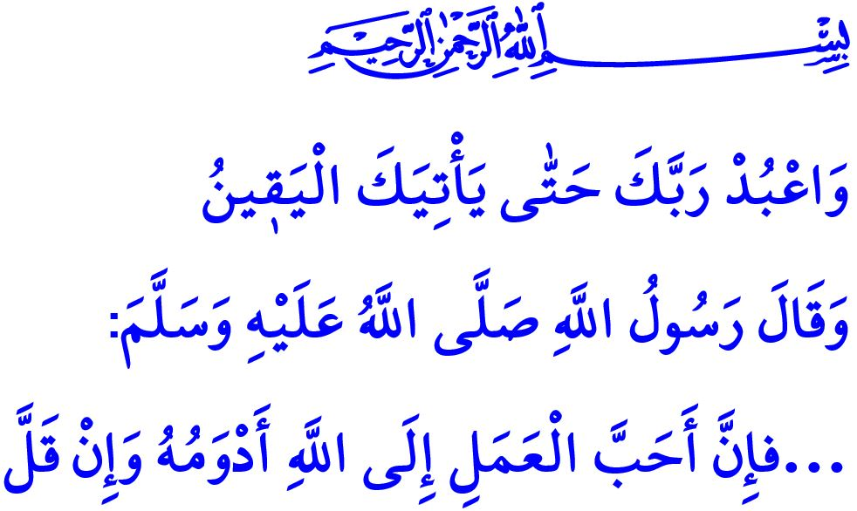
WORSHIP: AWARENESS OF
SERVITUDE TO ALLAH
Dear Believers!
In the verse I have recited, the Almighty Allah commands, “Worship your Lord until there comes to you the certainty (death).”
In the hadith I have recited, the Prophet Muhammad (saw) says, “The acts most pleasing to Allah are those which are done most continuously, even if they amount to little.”
Honorable Muslims!
Allah created human so they only worship Him. Servitude, or worshipping, means being fully aware of Him, connected to Him in heart, having faith in Him, and doing good deeds. The essence of servitude to Allah is to obey Him knowingly and willingly, as well as worship Him sincerely.
Honorable Believers!
Worship is the sign of the believer and the reflection of the faith on life. It is an indication of the desire to be closer to Allah and of the effort to become a good servant. It is the finest manifestation of love and devotion to the Almighty Allah. It is the expression of gratitude for the blessings and favors bestowed upon us by Him. It is to seek refuge in and to submit ourselves to Him, Whose forgiveness and mercy has no limits.
Dear Muslims!
People in servitude to Allah not only earn rewards for their worship, but also acquire several good dispositions and habits. Above all, worship raises in people the awareness of being always under supervision of Allah. It directs people to what is good, what is pleasant, and what is right. In fact, people who perform salah, knowing that they stand before Allah just as we will soon, feel responsibility. The salah they perform in awe of Allah distances them from extremisms and unpleasant deeds.
Similarly, fasting strengthens our willpower and increases our patience, in addition to enabling us to earn rewards of worship. It protects us from being a slave of our nafs, fancy and zeal, extending our hand for haram, and uttering unpleasant and evil words.
Worship of hajj and umrah instills the love of tawhid and sense of being a member of the Ummah while it reminds us of the Day of Judgment and its hardships. Every Muslim who removes and leaves behind casual daily clothes and puts ihram on for hajj and umrah makes sense of the fact that what is valuable before Allah is not property, authority, or position owned, but faith, worship, and good morality. Coming from all around the world with different languages, colors, and ethnicities, they stand shoulder to shoulder and feel deep in heart the divine appeal, “The believers are but brothers.” .
General Directorate of Religious Services
Zakat, sadaqah, and infaq, which are among the most valuable worships, purify and bless—increase the barakah of—the property. They enrich our heart, decrease our rush for worldly property, and increase our gratitude. Who saves oneself from self-centeredness and tightfistedness enjoys the taste of brotherhood when they share with other what they have in hand.
Offering a sacrifice helps Muslims get closer to Allah, allowing them to re-experience the Prophet Ibrahim’s loyalty and his son Ismail’s submission.
Honorable Muslims!
Humans, created to be in servitude to Allah, strive to deserve Allah’s approval through obligatory and supererogatory worships, aim to earn His contentment, and obtain His love. Ultimately, they receive The Almighty Allah's mercy, help, and protection. In a hadith qudsi, Allah states, “…the most beloved things with which My servant comes nearer to Me, is what I have enjoined upon him; and My slave keeps on coming closer to Me through performing Nawafil (praying or doing extra deeds besides what is obligatory) till I love him, so I become his sense of hearing with which he hears, and his sense of sight with which he sees, and his hand with which he grips, and his leg with which he walks; and if he asks Me, I will give him, and if he asks My protection (Refuge), I will protect him; (i.e. give him My Refuge)…”
Dear Believers!
In addition to the obligatory worships as daily prayers and fasting, any act done with good intention and sincerity in the hope of attaining Allah’s approval is regarded as worship. It is also a form of worship to maintain peace and trust in family at home, to make orphans and forlorn people happy, and to seek remedies for the problems of those in need. It is form of worship to work in order to provide our sustenance through halal ways, to say good words to people, and to be a compatible person. It is a form of worship to be honest in trade, to exchange greetings, and, even, to remove an obstacle that is tormenting people.
Honorable Muslims!
Being in servitude to Allah, which is the meaning and the purpose of our existence in the world, is an honor for us. We should fulfil our responsibilities with due diligence to be deserving of such honor. We should strive to keep alive the sense of servitude to Allah for our life. We should embellish our life with worships, good deeds and good morality. Let us always remember that Allah is always with us.

Hijr, 15/99.
Abu Dawud, Tatawwu, 27.
Dhariyat, 51/56.
Hujurat, 49/10.
Bukhari, Riqaq, 38.

